**Gender Inequality in Chinese State-Owned Enterprises: A Multi-Case Study Analysis**

Student’s Name

Professor’s Name

University Affiliation

Course Number and Name

Date of Submission

**Gender Inequality in Chinese State-Owned Enterprises: A Multi-Case Study Analysis**

**Abstract**

This research investigates gender inequality issues within Chinese State-Owned Enterprises (SOEs) through a multi-case study methodology. Employing qualitative data collection methods, including in-depth interviews and observational analysis, the study delves into the experiences of employees at two prominent SOEs, China Mobile Hubei Branch and State Grid Corporation of China. The primary research question revolves around understanding the extent and nature of gender disparities in these organizations, examining workplace dynamics, hiring practices, training initiatives, and the impact on career advancement.

**Methodology**

The research adopts a multi-case study approach, selecting China Mobile Hubei Branch and State Grid Corporation of China as the cases for in-depth exploration. Data is gathered through two in-depth interviews and an observation of a training session at State Grid Corporation of China. The interviews were conducted via Zoom, with the participant from China Mobile providing insights into workplace experiences, gender ratios, and hiring practices. The observational data stems from a training session on females in leadership roles, facilitated by Dr. Li Jiao at State Grid Corporation of China. The analysis utilizes NVivo software for thematic coding and pattern identification (Bazeley & Patricia, 2013).

**Analysis**

The training observed appears to have experienced a shift from the intended topic of females in leadership to a broader discussion on leadership and stress management. The lack of a collective reflection after participants shared their experiences and the absence of a clear link between stress management and the training's main theme led to confusion and disinterest among the trainees. The Q&A session also deviated from gender-specific concerns. The departure of two participants during the break may indicate dissatisfaction or a perceived lack of relevance.

**Findings**

1. ***Gender Composition***

China Mobile Hubei Branch reports a roughly equal distribution of male and female employees. However, male dominance is evident in leadership positions, with twice as many male leaders as female leaders.

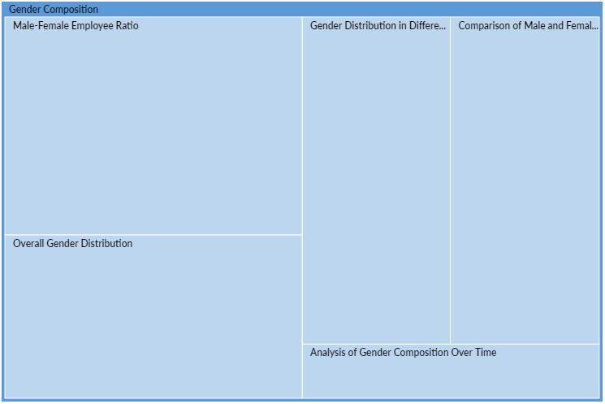

State Grid Corporation of China's training session on females in leadership roles was attended exclusively by female employees, emphasizing a gendered focus in professional development.

1. ***Hiring Practices***

Interviewees reported encountering questions about marital status during the application process, reflecting an underlying bias against female employees. Such inquiries are made discreetly, possibly impacting hiring decisions.

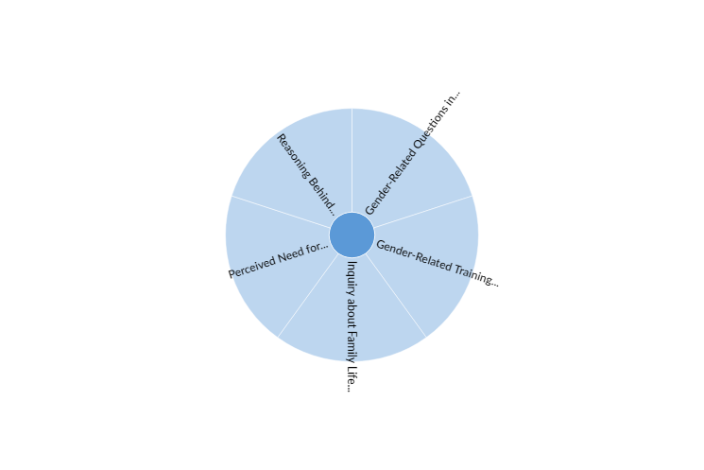

Despite the legal prohibition, there is a persistent belief that women are less profitable for SOEs due to assumptions about their eventual return to family roles.

1. ***Training Initiatives***

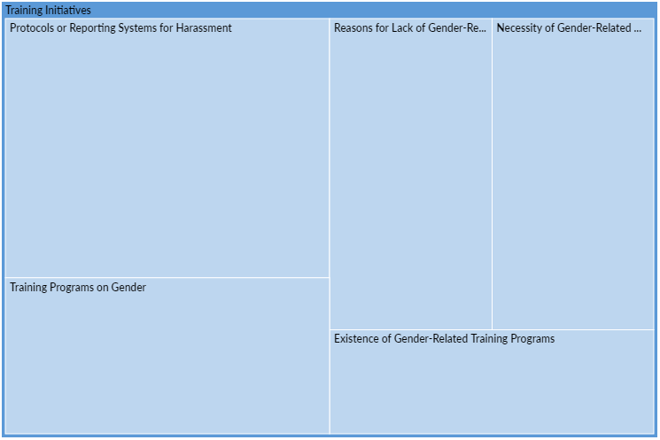

Both organizations show a lack of gender-related training programs, with a primary focus on Party culture and professional abilities.

Interviewees express the necessity of gender-specific training, particularly in preventing sexual harassment, citing past experiences of inappropriate behavior by male managers.

1. ***Workplace Culture***

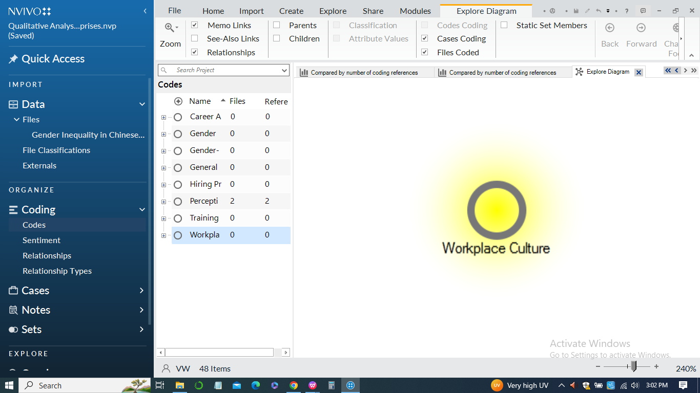

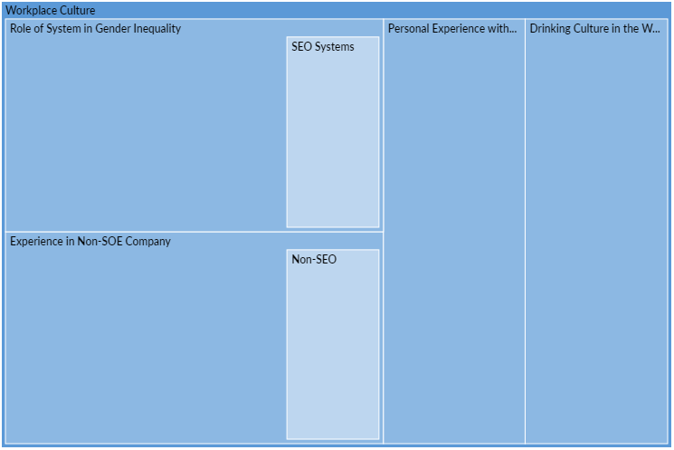

Observations reveal a nuanced drinking culture at China Mobile Hubei Branch, where traditional practices are less pronounced compared to other SOEs. This signifies variations in organizational cultures within the SOE sector.

Female employees at both organizations face gender-specific tasks and expectations, reinforcing stereotypes and perpetuating discriminatory practices.

**Interpretation**

The findings point towards a complex landscape of gender inequality within Chinese SOEs. While the gender composition appears balanced at the entry level, a clear disparity emerges at the leadership level, signaling potential barriers for female career advancement. The persistence of outdated hiring practices and the absence of gender-related training programs contribute to a workplace culture that marginalizes female employees. The observed drinking culture and gender-specific tasks further highlight the need for a comprehensive approach to address deeply embedded gender stereotypes. These insights underscore the urgency for SOEs to reevaluate existing policies and foster an inclusive workplace environment that promotes equal opportunities for all employees, irrespective of gender.

**References**

Bazeley, Patricia. 2013. Qualitative Data Analysis: Practical Strategies. London: SAGE. (Chapter 6 “Naming, organising, and refining codes”) Available as a hardcopy at the library 13.

Boyatzis, Richard E. 1998. Transforming Qualitative Information: Tematic Analysis and Code Development. SAGE. 14.

Jack, Tulia. 2020. Qualitative Coding and Analysis using NVivo PC/MAC Workbook. Lund University. Download from Canvas 6.

Charmaz, Kathy. 2006. Constructing Grounded Teory: A Practical Guide through Qualitative Analysis. SAGE Publications. Available as an e-book on the library website 15.

Fereday, Jennifer & Eimear Muir-Cochrane. 2006. “Demonstrating Rigor Using Tematic Analysis: A Hybrid Approach of Inductive and Deductive Coding and Teme Development”, International Journal of Qualitative Methods 5(1): 80-92. 16.

Glaser, Barney G., and Anselm L. Strauss. 1967. Te Discovery of Grounded Teory: Strategies for Qualitative Research. Chicago: Aldine Pub. Co. 17.

Strauss, Anselm L. 1987. Qualitative Analysis for Social Scientists. Cambridge: Cambridge University Press. 18.

Saldana, Johnny. 2015. Te Coding Manual for Qualitative Researchers. 3rd edition. Los Angeles; London: SAGE Publications Ltd. (Chapter 3 “First cycle coding methods”) Available as a hardcopy at the library

Bazeley, Patricia. 2013. Qualitative Data Analysis: Practical Strategies. London: SAGE (chapters 11-13; pp. 327-421). Available as a hardcopy at the library 3.

Braun, V. & Clarke, V. 2012. “Tematic analysis”. In H. Cooper, P. M. Camic, D. L. Long, A. T. Panter, D. Rindskopf, & K. J. Sher (Eds), APA handbook of research methods in psychology, Vol. 2: Research designs: Quantitative, qualitative, neuropsychological, and biological (pp. 57-71). Washington, DC: American Psychological Association. Download here 4.